Number System
Converter
COAL Fall 2025 Project
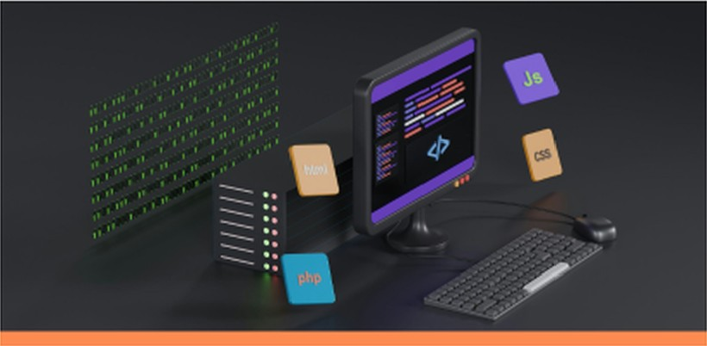

Talal Ali- 24k-0863
Syed Muhammad Sarim – 24K-0718
Shaheer Ahsan - 24k-0915


Table of Contents
 | Member
  Introduction | Contribution & key
 | outcomes

  Number System workflow | Function overview
  Function Explanation | Final verdict


Introduction


This MASM number system converter project makes use of the Irvine32 library. It is a console-based converter that provides binary and octal. decimal and hexadecimal conversions. Bitwise operations are also used in the project. IEEE-754 floating point to binary conversions, as well as title effects like pulses and UI animations like typing and loading.

Member
Contributions &
Outcomes

Syed Muhammad  Sarim  Floating-point conversion and overall menu system integration | Talal Ali  Number conversions from Dec to Bin/Hex/Oct and vice versa | Shaheer Ahsan  Signed number logic and bitwise operations implementation



Key Outcomes:
Functionality
Successful implementation of binary, Octal, decimal, and hexadecimal conversions using low-level arithmetic and register manipulation.


Optimization
Reduction of computation steps by optimizing loops. minimizing memory use and using CPU registers effectively for performance.

Reliability
Deployment of robust input validation techniques to handle invalid binary, hex and decimal inputs without program crashes.

Enhancement
Added bitwise operations and IEEE-754 conversion for enhanced functionality.

Number System Workflow
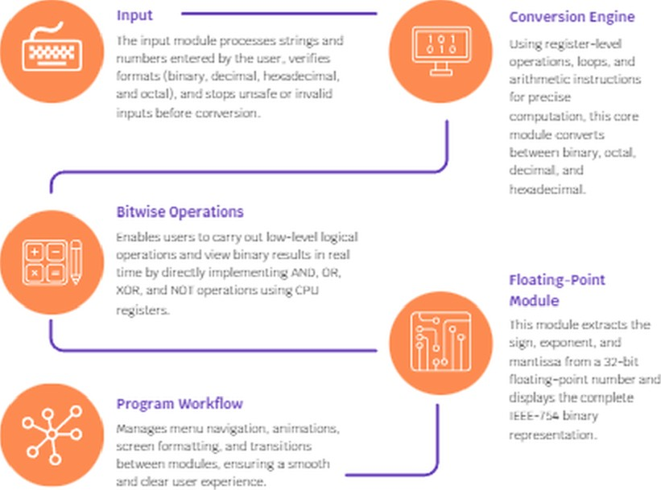

Function Overview
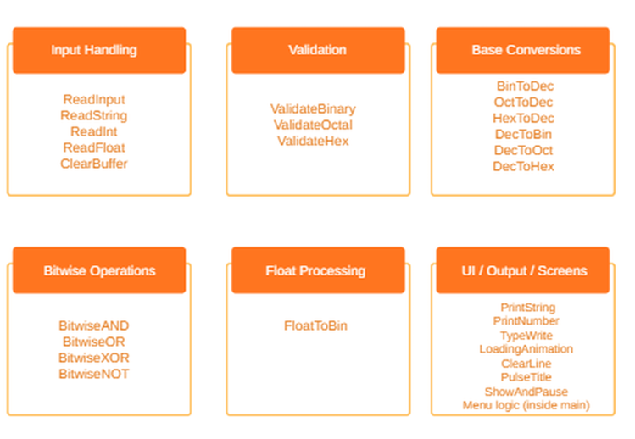

Function Explanation - I
Input handling
It cleans up every input buffer before any operation using the clear Buffer routine. Other UI
routines involve Typewrite for printing with animation, Loading Animation to create a sense of loading. Clearline to clear lines, and Pulse Title for adding colour effects. In this way, it feels
interactive.

Conversions
Core functionality covers several conversion routines: BinToDec, OctToDec, and HexToDec validate the respective input strings and convert them into decimal by bit shifting and ASCII-to value conversion. Vice versa, DecToBin, DecToOct, and DecToHex extract bits, octal digits, or hex nibbles by logical shifts and masks, building the respective string representations manually. These routines are demonstrations for low-level arithmetic and bit manipulation.
Bitwise Operations
It also realizes four bitwise operations: AND, OR, XOR, and NOT. Each function prompts forintegers from the user, performs the corresponding bitwise instruction, prints the result indecimal format, and calls the DecToBin function to display the binary form. This allows the user to see the effect that each bitwise operator has on underlying bit patterns.

Function Explanation - I l
Handling Floats
The procedure FloatToBin handles floating-point values: it reads REAL4 input. captures its raw 32-bit binary pattern and prints it bit-by-bit while separating the sign, exponent and mantissa fields. Then it extracts and prints these components separately to give a view of the internal binary structure of a floating-point number.
Display functions and main
The main procedure controls the program flow. It displays the title, prints the menu with a typewriter animation, reads in the user’s selection and branches to the appropriate operation. After each task ShowAndPause waits for a key press before returning to the menu. Option zero exits the program cleanly.

Conclusion & Takeaways
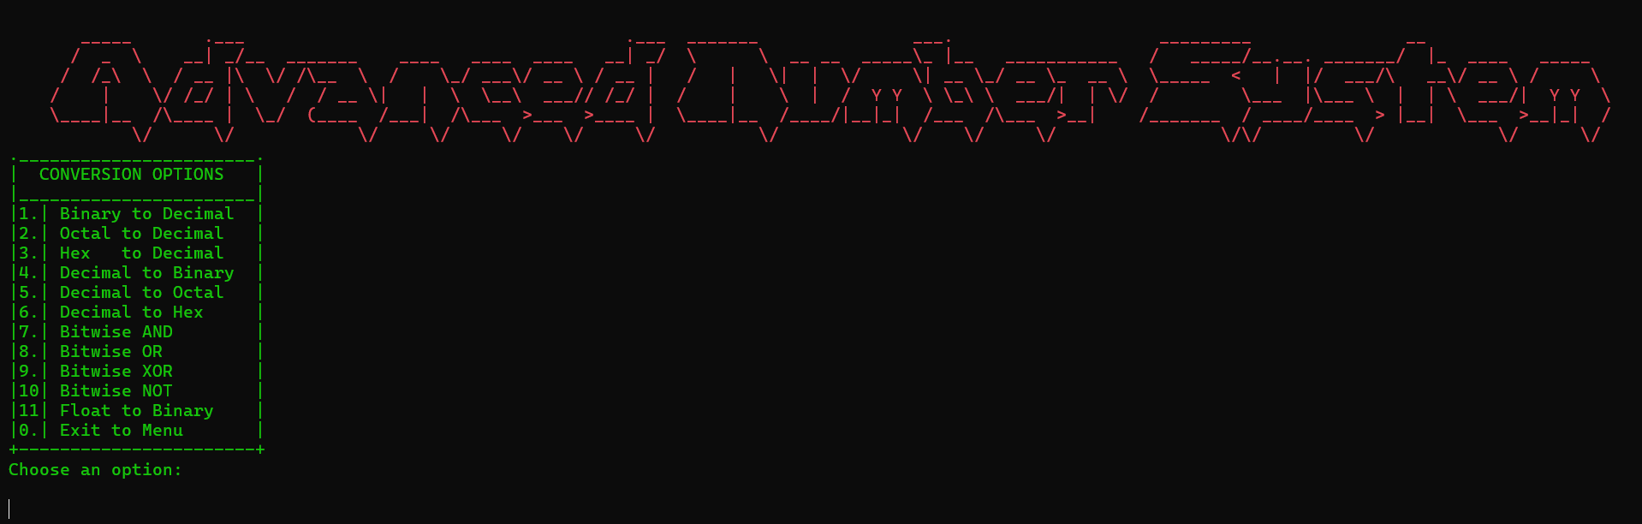
With the full implementations of number conversions, bitwise operations, and floating point decomposition through register-level operations, this Assembly project successfully combines technical depth with an approachable presentation. It demonstrates how the math functions on a machine level. Simultaneously, the animated interface, color effects and menu structure all show that Assembly can also provide an intuitive user experience if well thought out. All things considered, the program will be helpful as a working tool as well as a powerful demonstration of proficiency with low-level programming concepts, bit manipulation, data representation, and assembly language user interface design.
